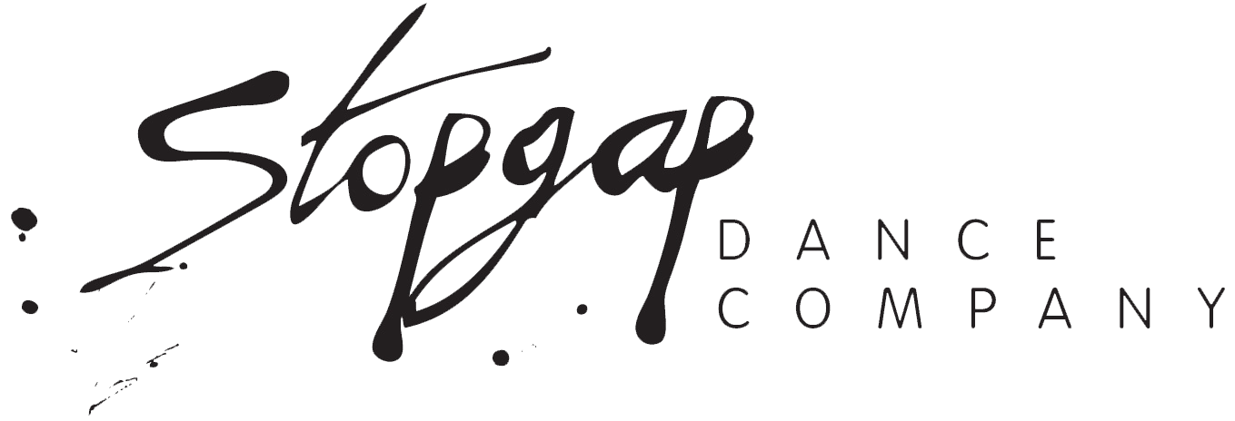

Inclusive Community Choreography: Alternative Application Information

- Stopgap are happy to accept applications in different formats eg. film or audio.
- This document contains the questions from our online form, please answer these questions in your preferred method.
- The personal and contact information should be submitted in writing either within an email or an attached file.
- Please submit your alternative application files via email as an attachment or a link to your recordings, keeping to around 5 minutes if possible.

If you have any questions or would like any support, please contact us.
Submit your application to admin@stopgapdance.com

Deadline for applications is Monday 24 August 2026.

Personal Information
Full Name:
Pronouns (optional):
Contact email:
Time Zone (if not in the UK):

Inclusive Community Choreography Questions
Please briefly outline any previous dance experience you have.
Please briefly outline any previous choreographic experience you have - (This can include being a dancer, it is also not necessary for you to have had any experience).
Do you have any experience in inclusive choreography? - If yes, please give more detail:

Your interests
What made you apply for this CPD?
Are you here to learn new information, or refresh what you already know?

Access Requirements
Do you have any access requirements you would like us to know about, so we can support your participation in the course?
As part of our access provision we will already have some support in place (see list on Community Choreography page). If there is something that is not mentioned that would be useful, please use this space now to request it.

If you would prefer to chat to someone about this instead, please contact joy@stopgapdance.com

Online safety
This section details the responsibilities that you, the participant taking part, have to agree to, to make our online Community Choreography training a safe place for everybody.
If you have any concerns, please contact Joy Ralph, Designated Safeguarding Lead - www.stopgapdance.com/contact

- Keep the Zoom link details and recordings private.
- Take responsibility for my own behaviour and language during sessions to create a welcoming space for all.
- Not share videos, pictures, or links that could be considered as threatening, bullying, or offensive behaviour.
- Keep my personal details (like passwords, phone numbers, or addresses) private, and keep other course members' details private.
- Not record, share, photograph, or take screenshots of sessions, participants, or course materials without permission.
- Report any behaviour that breaches this agreement to the course leaders.

I understand and agree to the above statements
YES / NO

During the training there will be opportunities to move. You will need to make sure you have a suitable space (it does not need to be big) so as not to injure yourself.
I agree to take full responsibility for my own well-being and safety throughout the online session.
YES / NO

We would like to record the training via Zoom. This is so participants can watch it back as a memory aid and for us as a record of content. This will be stored as a private unlisted video on Youtube and not shared externally.
I agree to the session being filmed and will not share the link with anyone external
YES / NO

Today’s date:

