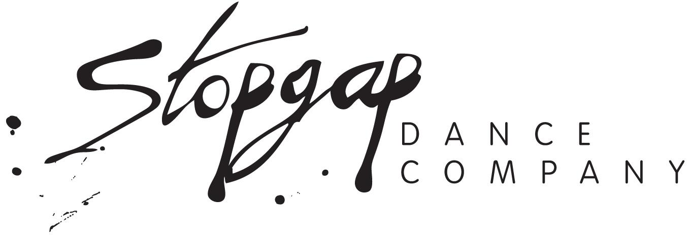

Access Worker Call Out

Stopgap Dance Company is looking to expand our pool of Access Workers.

We have one fixed, part-time role available and are also looking for those interested in working on a freelance basis.

The role of Access Worker would suit someone interested in social inclusion of Disabled people, and/or gaining professional experience in inclusive performing arts, contemporary dance, technical theatre, or arts management. These roles would suit people who consider themself to be calm, supportive, caring, patient, generous and nurturing.

About Stopgap:

Stopgap Dance Company is driven by a diverse creative team who uses dance as a movement for change. The company’s vision is to create an inclusive world where diversity is not just accepted but pursued, a world where no one is limited by prejudice against Deaf, Disabled, or neurodivergent people.

The company receives core National Portfolio Organisation funding from Arts Council England to devise and tour original dance productions.

For more information about the company please click here

About the roles:

These roles will support different members of the Stopgap team.

The fixed-term role will work with Chris Pavia - a choreographer, teacher and dance artist with Stopgap who has Down syndrome. Chris’ role includes working on his own productions that are produced by Stopgap; planning and teaching workshops; teaching and supporting Stopgap’s Youth Companies; taking part in discussions and giving talks at events; attending meetings and writing blogs and articles.

The freelance roles will work with other members of the Stopgap team including Hannah Sampson, Senior Dance Artist with Stopgap who has Down syndrome, and Laura Jones, Co-Artistic Director of the company, who is a wheelchair user. The work available on a freelance basis could range from a one day event to a project over a number of days or even weeks. These jobs would be booked in as much advance notice as possible and agreed with you.

Hannah’s role includes touring in Stopgap’s main company indoor and outdoor productions; studio time; presentations and teaching workshops.
Laura’s role includes delivering inclusive dance practice; Equality, Diversity and Inclusion/Access training and consultation; Creative Learning and GCSE dance workshops; Developing the IRIS Syllabus and overseeing the Youth Companies.

Important Information:

Closing date: Thursday 5th September at 10am
Interviews will take place on: Monday 16th September
Start Date for Fixed Term role: As soon as possible

Salary: £11.44 plus 12.07% holiday pay per hour (total: £12.82)

Location: Stopgap is based at the Farnham Maltings in Surrey. These roles will involve face to face support work in studios, primarily around Surrey, West Sussex and Hampshire. The freelance roles will also involve travel nationally and, on occasion, internationally

Equal Opportunities: Stopgap Dance Company is a keen advocate of Equal Opportunities in all aspects of our work. In order to analyse how well the company is reaching out to candidates with a wide range of backgrounds, it would be hugely useful if you could fill out an equal opportunities form here.

More information: If you have any questions about the role then we can respond via
email or over the phone. Please email admin@stopgapdance.com or call the office
on 01252 745443 and ask for Amy Owen

Duties:

The duties of the individual roles will vary dependent on the person that is being supported, but will include:

General Admin Support:

- Creating and sending weekly schedules and ensuring they have been received and understood
- Booking travel including taxis
- Liaising with Supported Independent Living houses
- Providing assistance on admin tasks in person and remotely
- Assisting in taking notes and capturing actions during meetings and while working in the studio
- Helping to create Easy Read / Plain English documents
- Supporting with time management
- Support with navigating and using the company’s HR system, Google Calendar and Asana project management

General Practical Support:

- Assembling and disassembling the person’s wheelchair as they arrive and leave
- Assisting with carrying any belongings and small tasks like filling up water bottles, etc
- Personal morning and evening care while away on overnight trips (experience not necessary)
- Getting lunch if the artists need to rest at lunchtime
- Advocating for the needs outlined in the artist’s access rider, ensuring they are being met and responding proactively when they are not

Studio Support:

- Assisting with explaining, demonstrating and translating dance tasks and exercises
- Support with interpreting and acting on creative tasks in the studio

Travelling and Touring/Working Away Support:

- Supporting in-person with travel
- Assisting with travelling abroad and orientation of new situations involving new people, places and cultures
- Supporting with self advocacy while in the studio and when on tour
- Support the Technical Stage Manager and the Production Manager with the day-to-day running of performances while on tour

Teaching and Creative Learning Support:

- Supporting to plan and teach at Stopgap's Youth Companies sessions
- Supporting with more general duties within the Youth Companies including helping set-up and clear the space; supporting participants who need 1:1 support; helping facilitate group work and helping make sure everyone’s voices are heard when working on creative tasks and performing in the annual Community Dance Platform in December with the groups
- Supporting with planning; scheduling; travel and teaching for any external workshops at schools, colleges and for other companies

Person Specification:

- Good interpersonal skills and the ability to work as a team member.
- Empathetic, willingness to help and a collaborative attitude are the most important attributes required in these positions
- Calm, supportive, rational and sensible, caring, easy going and nurturing personality
- Excellent communication skills including good listening
- Curious and a desire to learn
- Patient and generous nature
- Being able to work on own initiative and problem solve in the moment
- Good organisational skills; ability to plan, prioritise and meet deadlines; ability to stay calm and positive under pressure
- Confidence with IT systems such as Google Suite, Zoom, Asana etc
- A commitment to implementing Stopgap’s equal opportunities policy and a belief in and ability to communicate Stopgap’s mission and ethos across all company activity

Essential:

- Located in Surrey or nearby and happy to travel

Desirable but not essential:

- Full clean driving licence and use of car for work purposes (with full Business cover insurance)
- Valid passport and willingness to travel internationally on occasion

How To Apply:

Please write (no more than 1 page) or record (video or audio maximum of 5 minutes) an expression of interest letter outlining why you would be suitable for the role of Access Worker in relation to the personal specification above and are interested in working for Stopgap Dance Company.

Please include whether you are looking for a part-time, fixed role or whether you are more interested in the freelance roles. Please also indicate if you are happy to travel, with occasional overnight stays (both in the UK and internationally)

Please send your expression of interest and your CV to Amy Owen on admin@stopgapdance.com by the deadline.

Stopgap Dance Company is particularly keen to receive applications from people who consider themselves to be in minority groups or be in disadvantaged circumstances.

